**Dynamic Demographic Analyzer**

For MapInfo Pro v2021.1

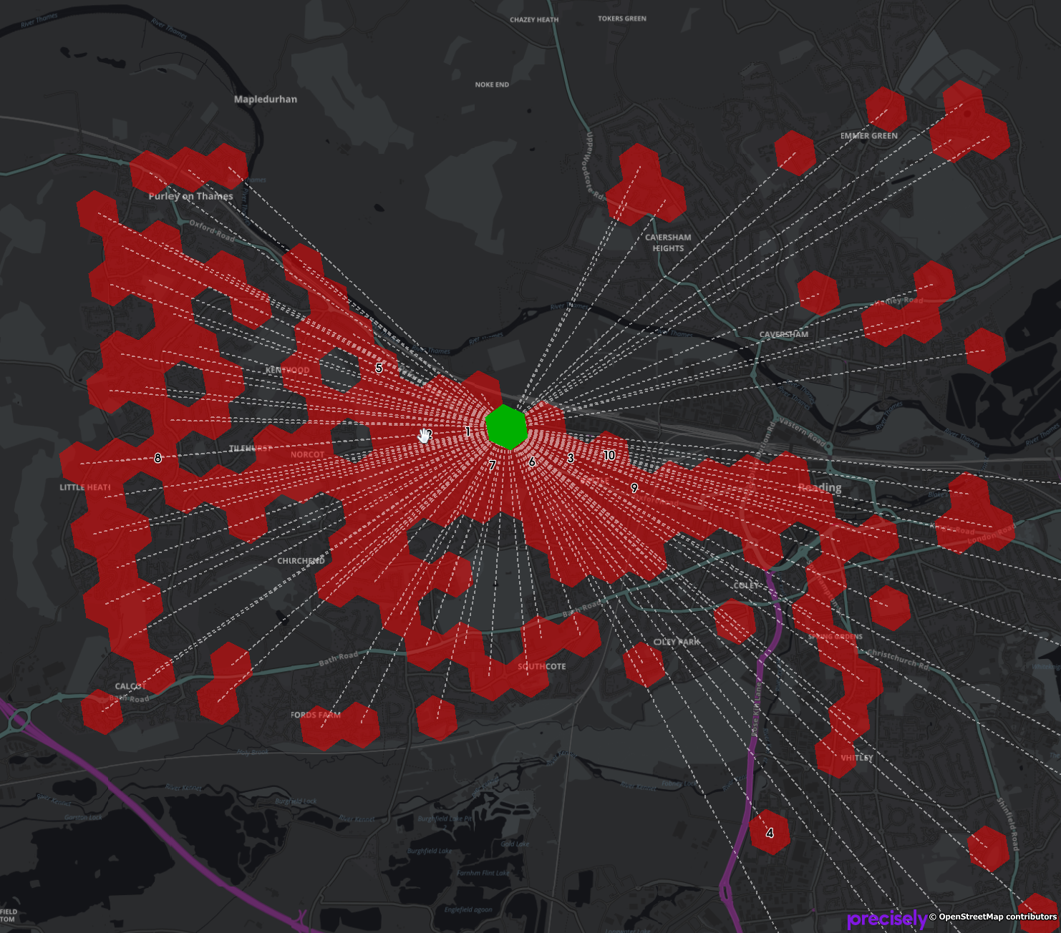

# Installation

<yet to be added>

# Data Samples

Precisely Dynamic Demographic Data samples can be downloaded from the Precisely Data Experience:

<https://data.precisely.com/home>

You need to create an account to be able to find and download data samples.

# Loading Data

When you get the Dynamic Demographic Data, either as full datasets or as sample datasets, it is in the form of TXT files.

The Dynamic Demographic Analyzer can help you convert these text files into extended native MapInfo tables that can be used by the tool.

The data when unzipped comes in a given folder structure that you need to maintain for the application to be able to work with the data.

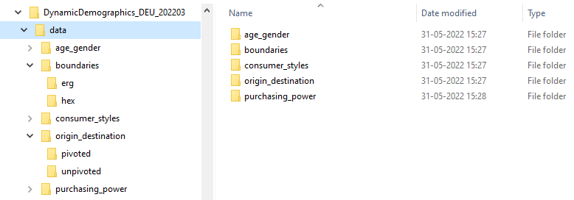

When the Dynamic Demographic Analyzer tool asks you to locate the folder with your data, it is the data folder shown above that you need to select.

The data folder contains the available data for the country you have data available for. For the sample datasets, you get a subset of the data for the country, typically data for a single city.

To load the data into a form for the Dynamic Demographic Analyzer can analyze, access the ***Data Loading…*** option from the context menu of the application in the ***Tools*** window.

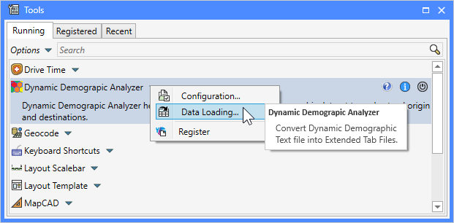

When you click this menu item, the dialog ***Load Data from TXT*** will appear. This dialog allows you to control what elements of the data you want to load into native MapInfo tables.

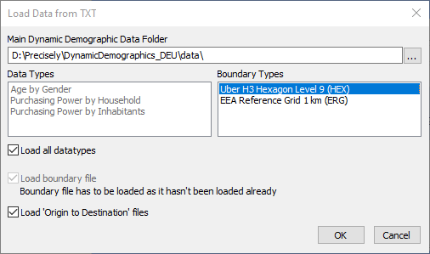

First, you need to point the ***Main Dynamic Demographic*** ***Data Folder*** to the folder described above containing the data.

This will prompt the dialog to load the available datatypes and boundary types and show these in the dialog. The data types and boundary type might differ from country to country.

You can either pick a single ***Data Type*** to load, or you can check the option ***Load all datatypes*** to load all the available data files into MapInfo tables.

Next, you will have to select what boundary type you want to load using the ***Boundary Types*** list. Above you can see that I have selected the Uber H3 hexagons. Also note that once you select a boundary type, the option ***Load boundary file*** might get checked and disabled. This will happened if the boundary file hasn’t already been loaded. If it hasn’t, it needs to get loaded as it will be used to enrich the data files with a boundary.

# Configuration

To access the ***Configuration*** dialog, click on ***Configuration…*** from the context menu of the application in the ***Tools*** window.

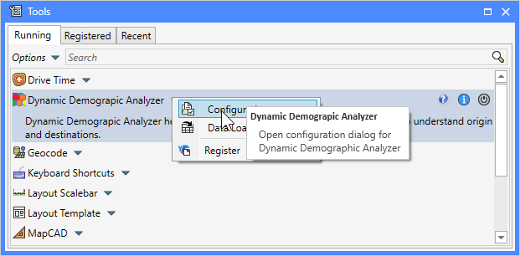

This will bring up the ***Configuration*** dialog.

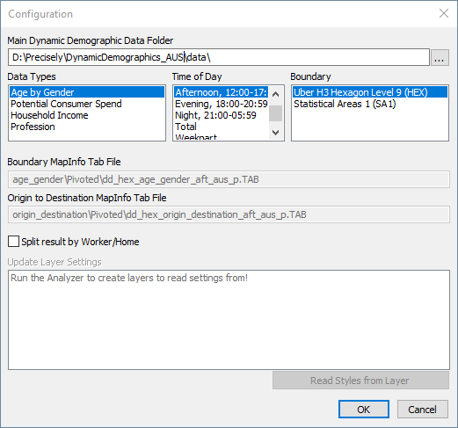

Here you can select the location of the ***Precisely Dynamic Demographic data folder***. It’s important that you have loaded the data into native tab files before using the ***Configuration*** dialog. Otherwise the application will not be able to locate the tables that are to be used.

After selecting the data folder, the dialog will load the available data types, the dayparts and the boundary types so that you can select from these.

Once you have selected from these 3 options, the dialog will show the name of the native tab files that will be used in your analysis.

Do note that not all ***Data Types*** supports all ***Time of Day*** options. If the field for the ***Boundary MapInfo Tab File*** is empty, it means that the specified file con not be found. You may have to select a different combination of input or you may have to run the Data Loader again to get the data loaded.

If you have performed some analysis and have the resulting query tables open in the active map window, the list ***Update Layer Settings*** will show these resulting layers. You can now use the dialog to read and store the layer and label settings from these layers and use these settings for your next analysis.

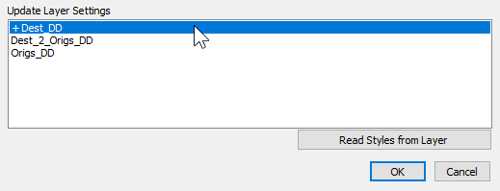

Select a layer from the list and click the ***Read Styles from Layer***, or simply double-click on the layer. This will add a “+” in front of the layer name indicating that the layer settings will be read from this layer when you click on the ***OK*** button.

# Analyzing Locations

From the ***Map*** tab, you can select one of the two buttons to analyze the Origin to Destination data.

Select the appropriate tool, and click in the map for the desired destination or origin location.

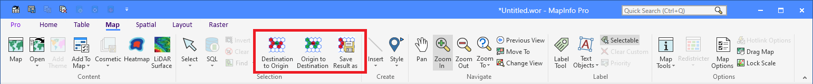

The tool will now find the matching origins, or destinations, and also draw lines between the point where you clicked and these locations. 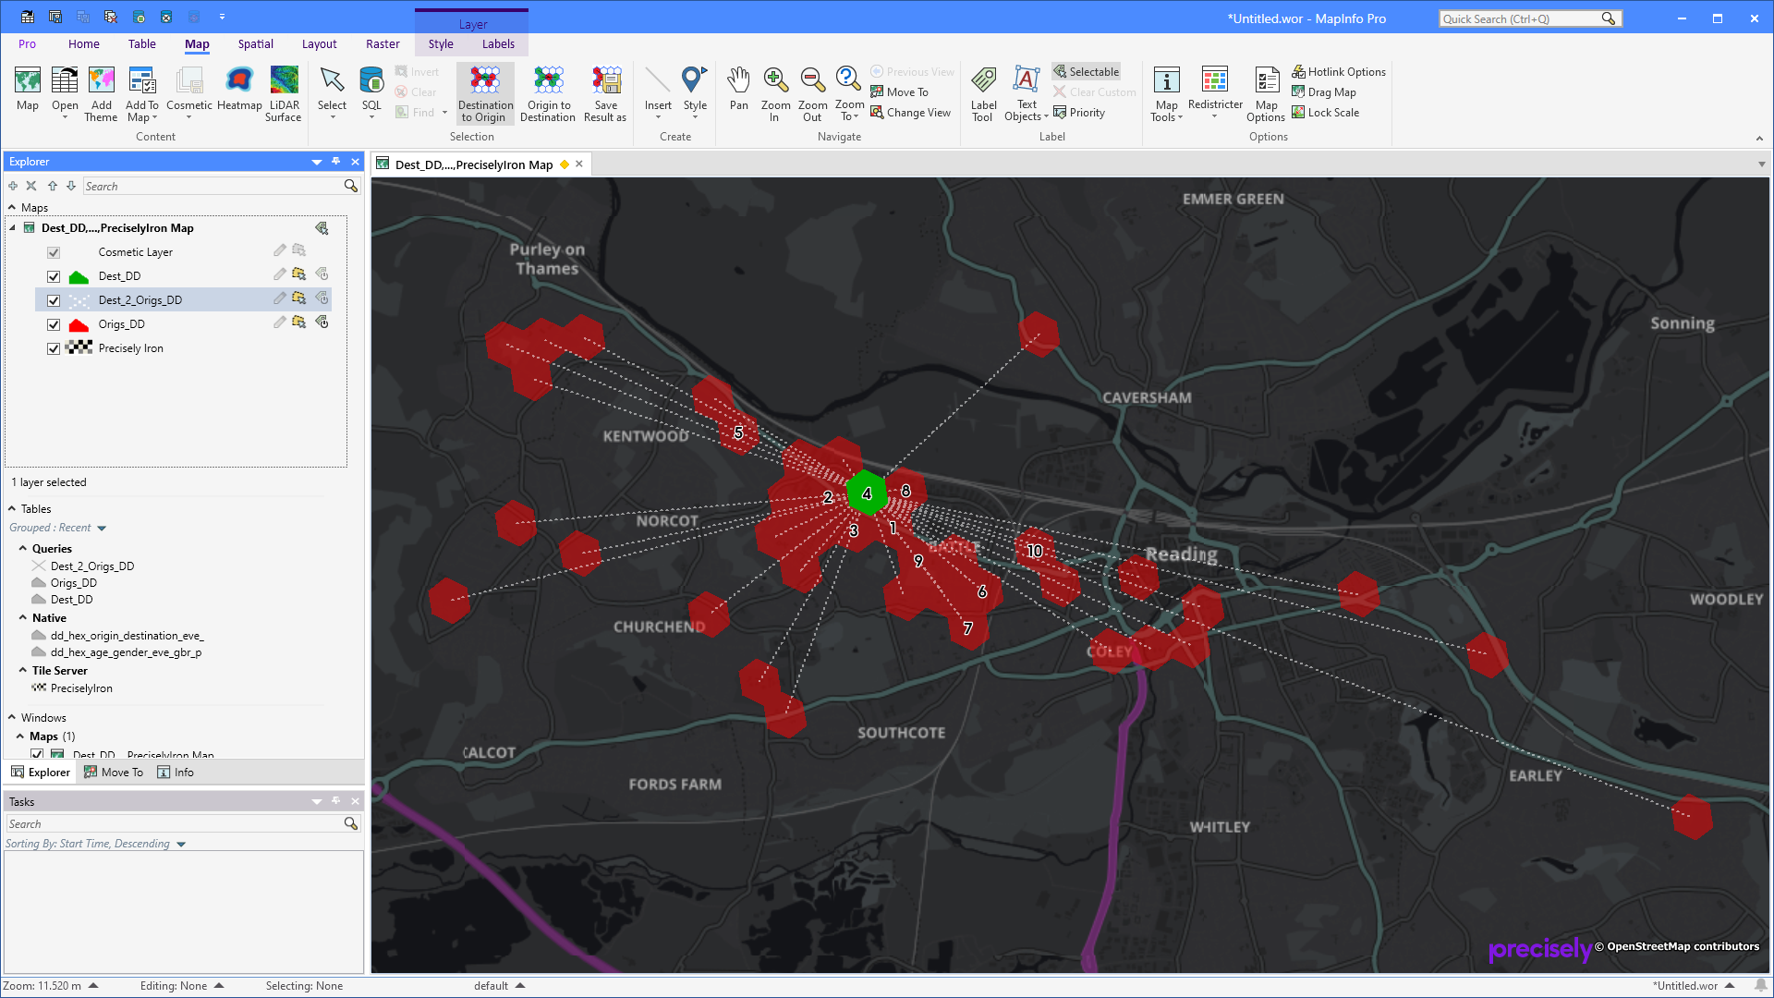

# Saving Analysis Results

You can save your analysis results using the ***Save Results As*** from the ***Map*** tab.

Click the control and specify the location where you want to store the result, and the name of your project. The given name will be used as part of the saved native tables.

Once the tables have been saved, the temporary query tables will be closed and the saved native tables will be opened in their place.

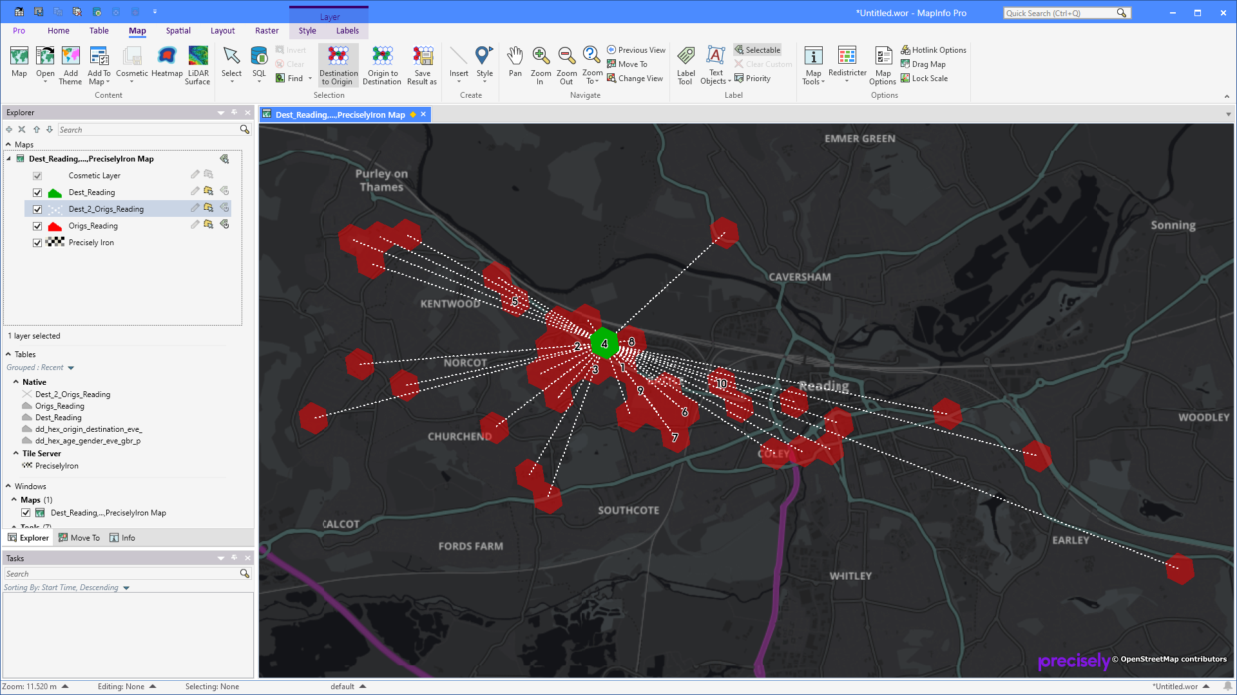

# Source code

The source code for this tool is shared via GitHub:

<https://github.com/PeterHorsbollMoller/mbDynamicDemograpicAnalyzer>

That means that you can grab the MapBasic source code and use this to improve the existing or build your own application to work with the Precisely Dynamic Demographic data set.

# Known Issues

Label expression is an issue as many columns also contain the daypart as part of their name. This makes is difficult to have one label expression for each of the 6 layer types (origin, destination, origins, destinations, origin to destinations and destination to origins). It almost seem that we need to store for each layer type and then split these by daypart, and maybe even per data type too.

# Improvement List

## Wish List

* Allow the user to see all the morning, afternoon, evening and night origins for either weekday or weekend in one view (different colour for each day part – you could also colour the lines with an offset for each so you can see where they share the same destination
* Improve the way label settings, especially label expression is stored as the column names seems to differ across the different daypart tables.
* Change the way styling is handled to only store it for the main categories: origin, destination, origins, destinations, origin to destinations and destination to origins. Currently styling is also split by combined, work and home for each of the 6 layer types
* Data types should be moved to a configuration file so that it easily can be extended when necessary. Currently the list of data types is hardcoded in the application
* Boundary types should be moved to a configuration file so that it easily can be extended when necessary. Currently the list of boundary types is hardcoded in the application
* When saving your result into native tables, the tool should check if tables already exist using the specified name.
* You should be able to select multiple Time of Day elements and when doing so, the tool should merge the columns from the selected Time of Day tables into the selected origin/destination. Alternatively, the user should be able to enrich a subset of boundaries with data from other data files, say they have used the morning file, and now they want to add the afternoon, evening and night values too, or even add values from other data types too. Need to keep count of the number of columns as the maximum is one thousand.
* Investigate if Excel could be used to creating graphs for the selected origin/destination.
* Check that the folder exists to avoid showing this dialog:

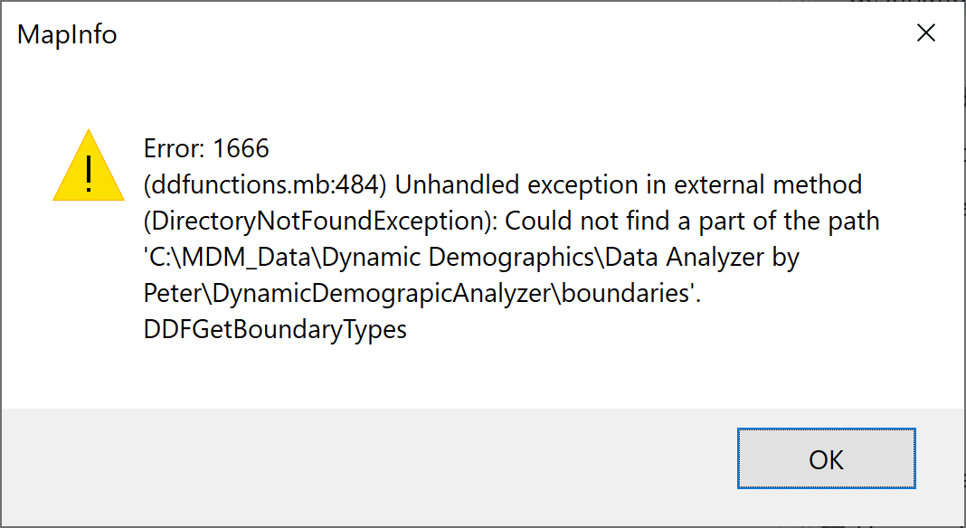

## Version 1.5.2

The Data Loading option now also converts the TOT (Total) and WPT (Weekpart) files into MapInfo Native tables.

The Configuration dialog now allows you to select not only morning, afternoon, evening and night, but also Total and Weekpart. These additional table split typical only exists for the Origin-to-Destination tables. This also means that you currently can’t select these if your boundary tables are split by time of day too. Unless the boundary table also holds these splits.

## Version 1.5.2

Fixed an issue with numeric values being used for the AREA_ID for some boundary types.

## Version 1.5.0

A new feature has been added to the tool. The feature Data Loading makes it possible to convert the delivered TXT files into native MapInfo tab files. The user can control which data files should be converted. This conversion also works for sample data and makes it possible to download the TXT files, convert these using the tool and then start using the Dynamic Demographic dataset in MapInfo Pro.



The Configuration dialog got another update. You can now also select the boundary type that you want to use. The list is automatically published using the boundary types from the ***boundaries*** folder.

Currently the tool supports these boundary type: HEX, ERG, SA1 and OA.

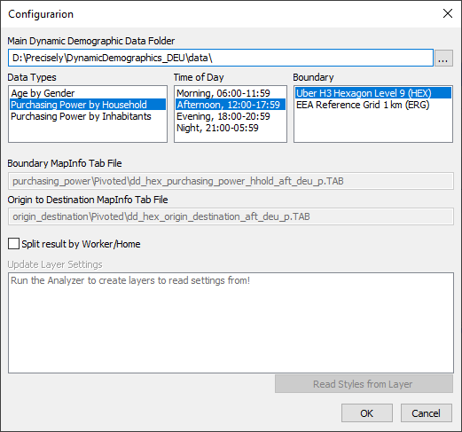

The option to save an analysis into a set of static tables has been improved. You now specify a name for your project which gives you the option to open up multiple analysis results at the same time as the name of the project will be used in the name of the analysis tables. Destination_DD will be renamed to Destination_LondonEast as an example.

The analysis tables have been shortened. Destination_DD will now be Dest_DD and Origins_DD will be Origs_DD. This makes it possible for longer project names when you save your analysis result.

If an error occurs when applying the label expression to the analysis layer, the application will now default to the first column in the layer.

The application now comes with documentation in the form of this document.

## Version 1.4.0

I know there has been a few issues with the latest version and I have tried to address these in this new release, v1.4.0. Some of the issues occur because the user pick the wrong input tables. I have tried to address this by changing the Configuration dialog to what you see below.

You no longer select the actual input tables, you select the Main data folder holding the different sub data folder. The application will then find and show you possible data types you have available. Below, you can see the data types for Australia which are different to those in England and Germany.

After selecting the Main data folder, the Data Types and Time of Day lists get published.

You can now select the data and time of day from these lists.

This is enough information for the application to pick the actual tables to use.

If you have multiple polygon types, hex and boundaries, for now you will have to separate these at the Main Data Folder level.

We can consider extending the tool to let you choose between multiple boundary types too.

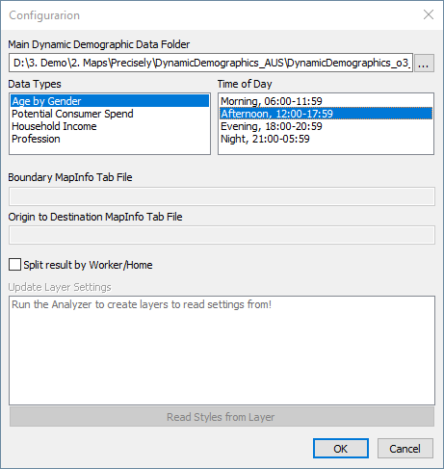

For now, the application will only work with Pivoted datasets. If it turns out to be, we can extent the application to allow you to select between Pivoted and Unpivoted.

The application now also checks for the AREA_ID column, it that isn’t found it will use DEST_AREA_ID instead. This was reported by the Australian team so I’m not sure if the same problem might have existed for UK and DE.

It spits out all sorts of debug messages to the Message window. To turn of these, delete the file DynamicDemograpicAnalyzer.dbg in the application folder.

## Version 1.3.1

Currently, the tool runs in debug mode. This means that I print a lot of debug information to the Message window.

You can look at this to see what queries I run to find the origins and destinations. You can also find this in this file in the application folder: DynamicDemograpicAnalyzer.dbg

Destination to Origin query:

Select * From dd_hex_purchasing_power_househ, dd_hex_origin_destination_aft_

Where dd_hex_purchasing_power_househ.Area_ID = dd_hex_origin_destination_aft_.Origin_Area_ID

And dd_hex_origin_destination_aft_.Origin_Area_Type = "Work"

And dd_hex_origin_destination_aft_.Dest_Area_ID = "89195d2b3c3ffff"

And OBJ

Into Origins_Work_DD NoSelect

Origin to Destination query:

Select * From dd_hex_purchasing_power_househ, dd_hex_origin_destination_aft_

Where dd_hex_purchasing_power_househ.Area_ID = dd_hex_origin_destination_aft_.Dest_Area_ID

And dd_hex_origin_destination_aft_.Origin_Area_Type = "Work"

And dd_hex_origin_destination_aft_.Origin_Area_ID = "89195d2b3c3ffff"

And OBJ

Into Destinations_Work_DD NoSelect

You can now control the display of the resulting query tables in the map yourself. Configure them to look as you want and then use the new Configure dialog to read and store the layer and label settings for the layers.

Checkbox in the Configuration dialog to control the Split by Worker/Home option

Option to save analysis result into static tables. This will save the analysis report query tables into native tab files in a chosen location, close the queries and open the native tab files in their place.

Below you can see the new button for Saving the Analysis Result into native tab files next to the two analysis tool buttons. And notice the Configuration option on the context menu of the tool in the Tools window

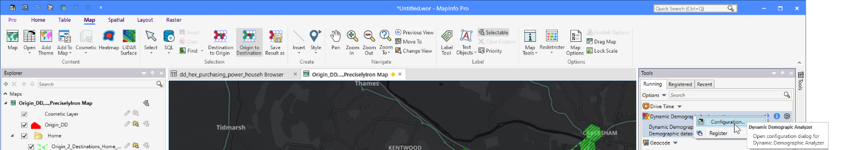

An example of how the result now can be represented with custom styles for the individual query results and support for labels, too.

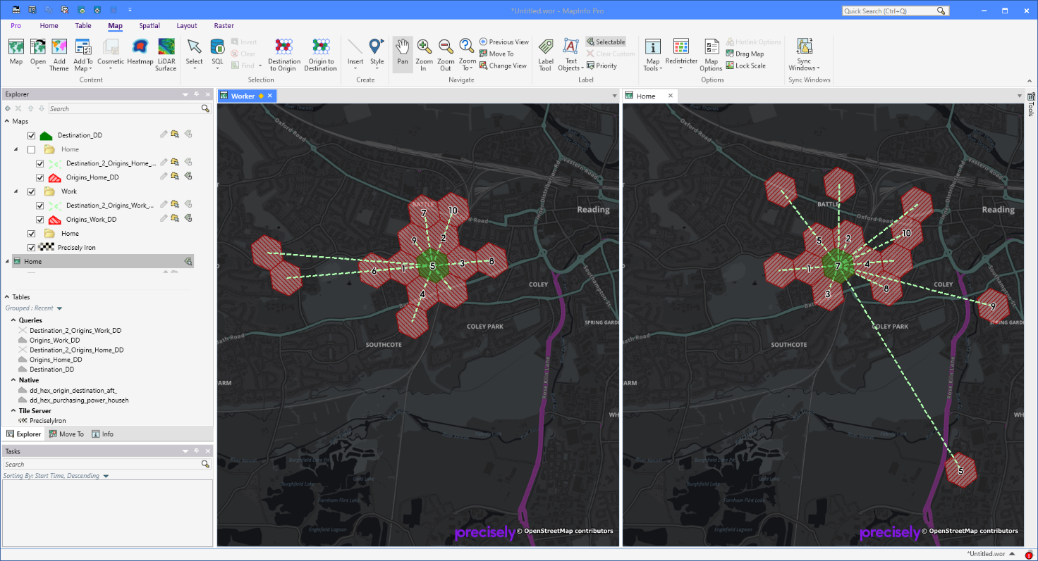

I have started gathering all the configuration in a single dialog. This is now also the place where you set the tables to use: The boundary table and the origin-to-destination table.

You can here also turn on/off the option to split the result by Home/Worker.

And finally, I have here added the option for you to read styles from the open layers and store these settings. Once read and stored, the application will use these settings when showing the result in a map moving forward.

In the dialog below, you can also see the result tables/queries for Destination to Origin. That’s because that’s the analysis I used before opening the dialog. If you have used the Origin to Destination analysis instead, it will be these tables you see in the dialog. If you haven’t done any analysis, the list of tables will be empty.

You can select a layer and use the button Read Styles from Layer or just double-click on the layer. When you have set a layer to be updated with layer settings, a “+” I shown in front of the layer in the list.

Note that reading the layer settings also read the label settings and can show labels for the polygons as you can see in the maps above.

I used an expression to only label the top 10 ranked hexagons (IIf(rank_d < 11, rank_d, ""))

